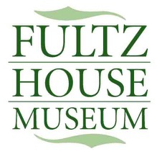

Charitable Tax # 118934215RR0001

All donations to the Fultz Corner Restoration (Fultz House Museum) are used for the maintenance, new development, and upkeep of the museum building, outbuildings, grounds, and collections. We are very grateful for donations we received. Please complete the form below for monetary donations so a tax receipt can be provided.

Donation Amount

Type of Donation In memory of

In honour of

No Dedication

Name

Street Address

City

Province

Postal Code

Email address

Phone Number

Donations can be provided by etransfer to [donate@fultzhouse.ca](mailto:donate@fultzhouse.ca) or cheque mailed to :

Fultz Corner Restoration Society

33 Sackville Drive

Lower Sackville, NS

B4C 0E5